I have selected bike_buyers dataset for this project.

Reading and high-level analysis:

*bike_buyers = read.csv('bike_buyers.csv', header=T, na.strings='')*

*head(bike_buyers)*

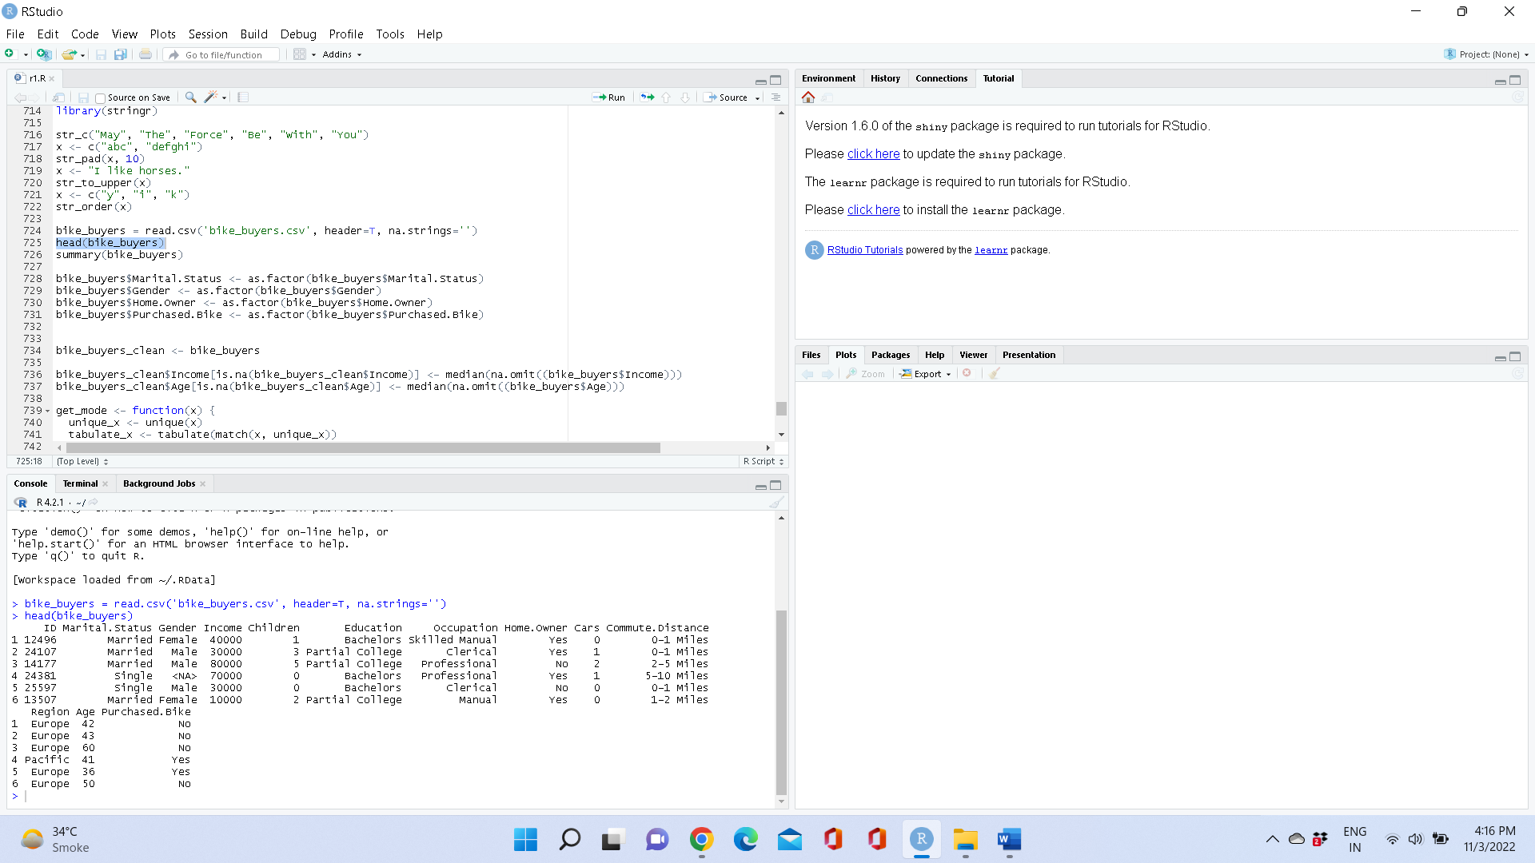

*summary(bike_buyers)*

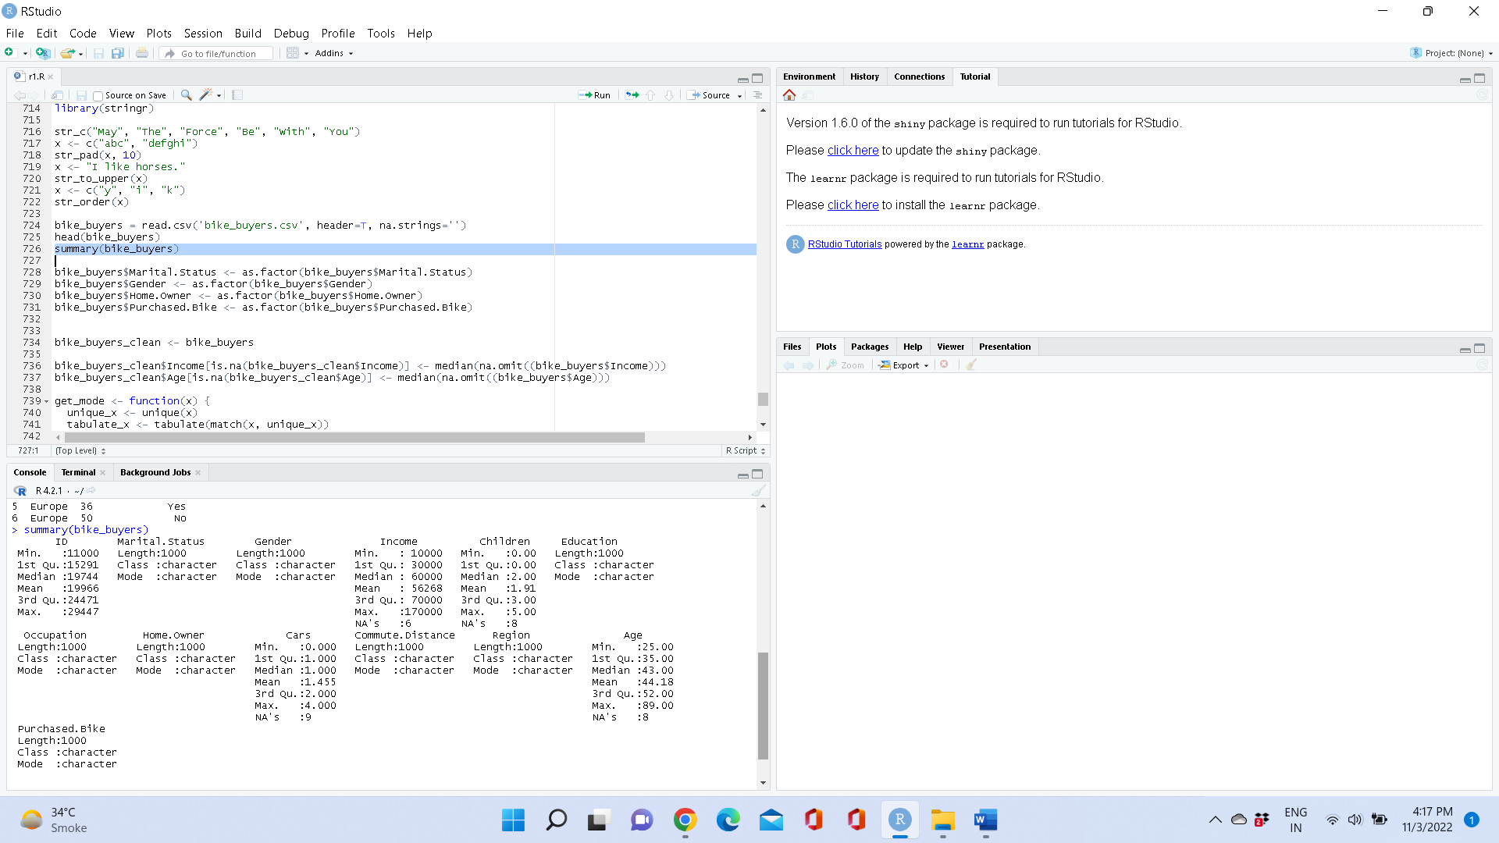

Assign Factors to String Values:

*bike_buyers$Marital.Status <- as.factor(bike_buyers$Marital.Status)*

*bike_buyers$Gender <- as.factor(bike_buyers$Gender)*

*bike_buyers$Home.Owner <- as.factor(bike_buyers$Home.Owner)*

*bike_buyers$Purchased.Bike <- as.factor(bike_buyers$Purchased.Bike)*

Dealing with NA values:

*bike_buyers_clean <- bike_buyers*

We will replace NA values in Age and Income feature with Median.

Replace NA values in Marital.Status, Gender, Children, Home.Owner with Mode.

Replace NA values in Cars from Mean

# replace with median

*bike_buyers_clean$Income[is.na(bike_buyers_clean$Income)] <-median(na.omit((bike_buyers$Income)))*

*bike_buyers_clean$Age[is.na(bike_buyers_clean$Age)] <- median(na.omit((bike_buyers$Age)))*

*get_mode <- function(x) {*

*unique_x <- unique(x)*

*tabulate_x <- tabulate(match(x, unique_x))*

*unique_x[tabulate_x == max(tabulate_x)]*

*}*

*# replace with mode*

*bike_buyers_clean$Marital.Status[is.na(bike_buyers_clean$Marital.Status)] <- get_mode(bike_buyers$Marital.Status)*

*bike_buyers_clean$Gender[is.na(bike_buyers_clean$Gender)] <- get_mode(bike_buyers$Gender)*

*bike_buyers_clean$Children[is.na(bike_buyers_clean$Children)] <- get_mode(bike_buyers$Children)*

*bike_buyers_clean$Home.Owner[is.na(bike_buyers_clean$Home.Owner)] <- get_mode(bike_buyers$Home.Owner)*

*# Cars replaced with Mean*

*bike_buyers_clean$Cars[is.na(bike_buyers_clean$Cars)] <- mean(bike_buyers$Cars, na.rm = TRUE)*

*summary(bike_buyers)*

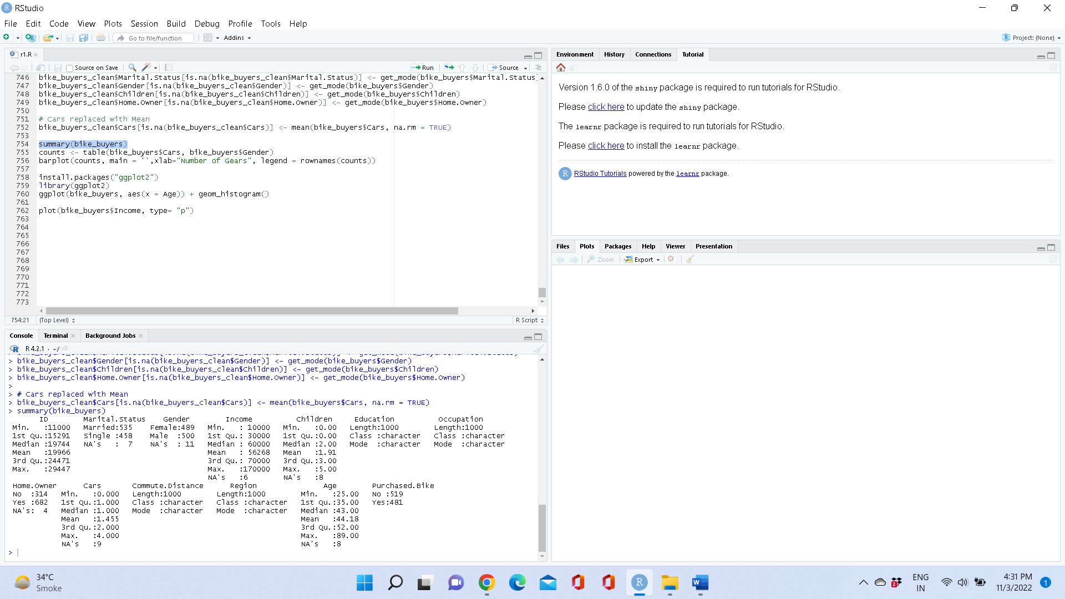

Visualizations:

*counts <- table(bike_buyers$Cars, bike_buyers$Gender)*

*barplot(counts, main = '',xlab="Number of Gears", legend = rownames(counts))*

*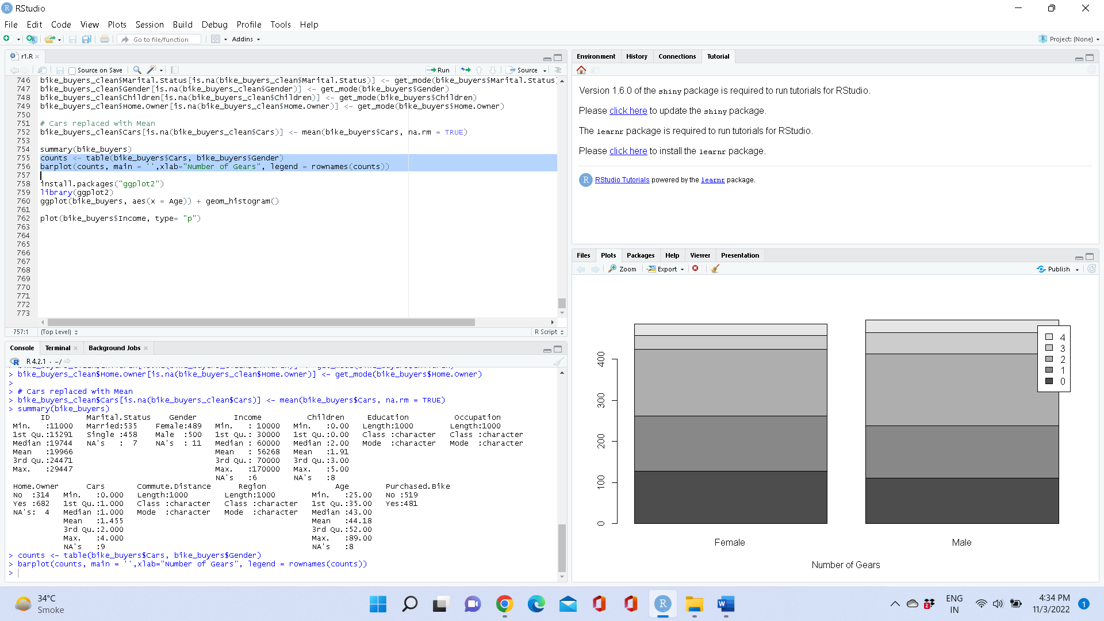*

**Conclusion: There is no much difference in number of Male and Female bike buyers.**

*install.packages("ggplot2")*

*library(ggplot2)*

*ggplot(bike_buyers, aes(x = Age)) + geom_histogram()*

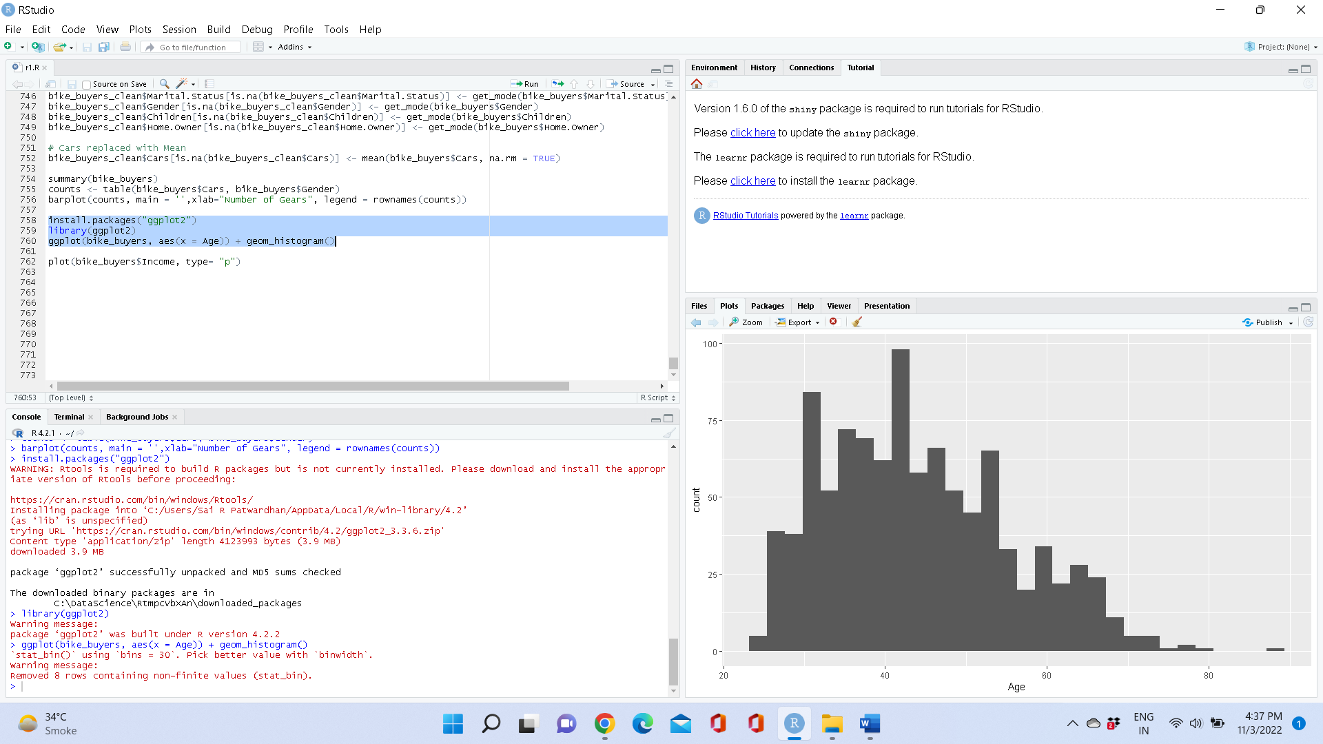

**Conclusion: Most buyers are between 30-50 years of age.**

*plot(bike_buyers$Income, type= "p")*

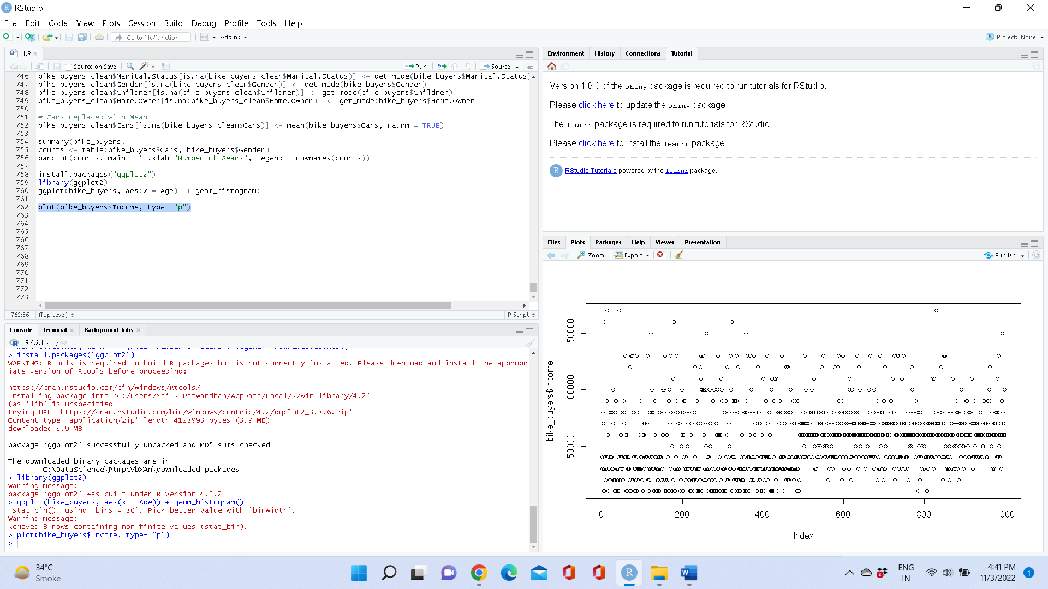

**Conclusion : People with higher income don’t purchase bike.**